Mini-Guide to the Clean-Up Options for Bingham Park Draft 5-20-21, revised 10-29-21 for Ms Pat
 | Option 1: Cover System | Option 2: Cover System and Maintain Trees* | Option 3: Cover System  and Replant Trees | Option 4: Waste Removal  and Optimal Backfill | Option 5: (In Progress) Partial Waste Removal and Backfill
What happens to the contaminated soil? | The soil stays in place and is covered up with a strong plastic covering and an HDPE grid. Soil and grass go on top of that. (see photo below). HDPE stands for “high-density poly-ethylene”, which is a hard, strong plastic. | Same as this  ← | Contaminated soil is removed from some areas of the park and moved to other areas (concentrated there). In the places where the contaminated soil was removed, new soil is added. In the concentrated areas of contaminated soil, the strong plastic covering is placed and covered with soil and grass. (see Option 3 plan below) | Contaminated soil is removed from almost all areas of the park (except right around the AT&T fiber optic line). New soil is added to the park. | Parks and Rec/Field Ops estimating what the costs and feasibility would be of removing soil from some large areas of the park and replacing with clean fill. Other areas would have the GeoGrid.
What happens to the trees? | Trees are removed and new trees can’t be planted where the plastic covering is. | Some mature trees could be left in place. They could be growing in soil that is contaminated, though. | Trees can be planted in the areas where contaminated soil was removed (this is the purple area in the plan below). Trees can’t be planted in the areas where the plastic covering is (orange area in plan). | Trees can be planted in almost all areas of the park (except right around the fiber optic line). | Getting second opinion from the urban arborist.
What happens to the stream? | The work on the stream is the same for all 4 options. The waste on the banks is removed and replaced with clean soil and plants. Most of the stream banks would be leveled out so that they are not as steep as they are now. A 300-foot section of the south bank of the stream would be leveled out and reinforced with concrete to protect a sewer line from erosion.
What could we have at the park afterwards? | Walking paths, benches and other features would be possible, but you can’t have items that need to be anchored in the soil (like play grounds). What about basketball courts? Picnic shelters? | Same as this  ← | Same as Option 1 and 2 in the areas where there is a plastic covering.  Items that require anchoring in the soil (like playgrounds, shelters, bathrooms?) could possibly be added to the areas where the soil was removed. | More options for park facilities and features would be possible with this option, including items that would be anchored into the new soil, such as water fountains and restrooms. | Community needs to identify what areas would be best for removal (such as basketball court)
How much would this cost? | $6,986,564 | $7,655,861 | $8,829,800 | $31,000,000 up to $131,925,266 (depending on quantity of hazardous soil) – this may be inflated because the city may be able to do this more cheaply – depends on how the waste is classified and which type of landfill can hold the contaminated soil | To be determined
How long would this take?
Picture of an example of the strong plastic covering (orange), HDPE (high-density poly-ethylene) grid (black) and clean soil (tan) on top.
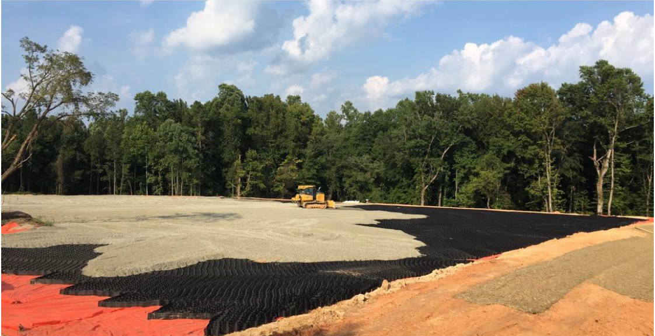

Option 3 Drawing. The purple striped area would be where existing soil is removed, moved elsewhere in the park and replaced with clean soil. In the orange areas, contaminated soil would remain and be covered with strong plastic, the black grid, and the soil and plants on top. You can also see the dark gray section on the stream bank that would be reinforced with concrete (this part is that same for all 4 options.)

